Software and driver installation
- Arduino programming software installation
Open “development software” folder. You can see two versions. One is 0023. You don’t have to install this version. Just copy the folder to the root directory of disc C or D. 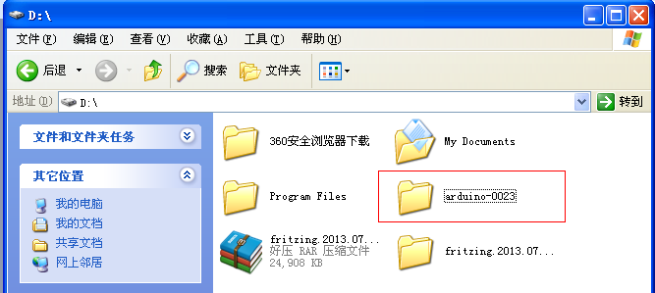
Then open this folder. 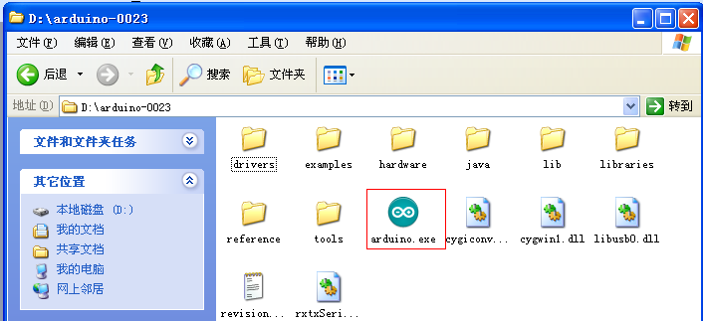
Click Arduino.exe, and then right-click “ add to desktop shortcut” .
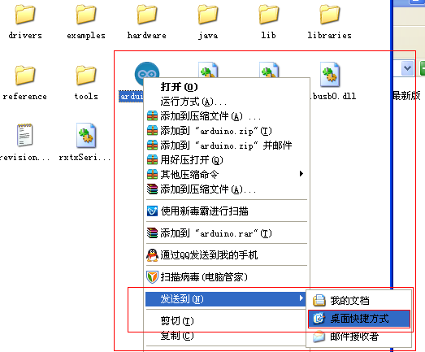
In this way, you can use the software already. Below picture is how it looks when you open it.
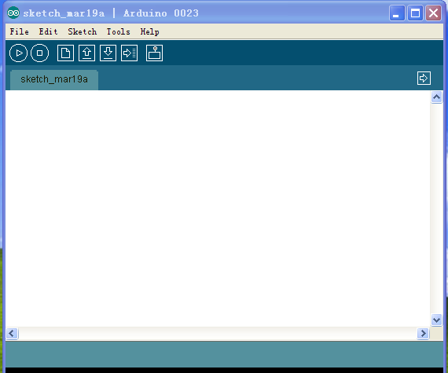
Below is the installation for Arduino1.5.6:
open “development software” folder, you can see folder “Arduino-1.5.6 newest version” , double click Arduino-1.5.6 .exe.
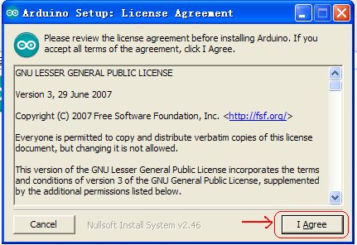
Then
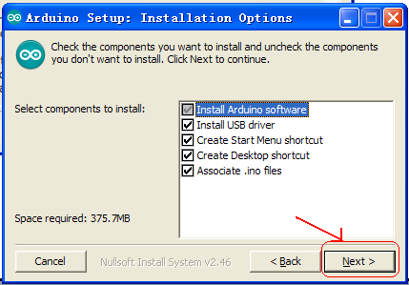
And then
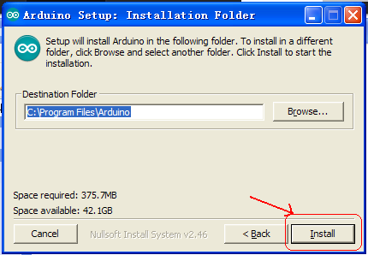
Wait until the installation is complete and click close to finish the installation.

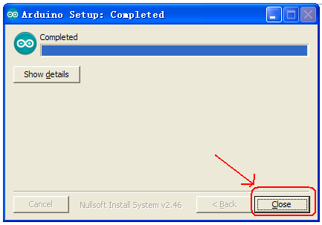
Below picture is how it looks when you open Arduino 1.5.6: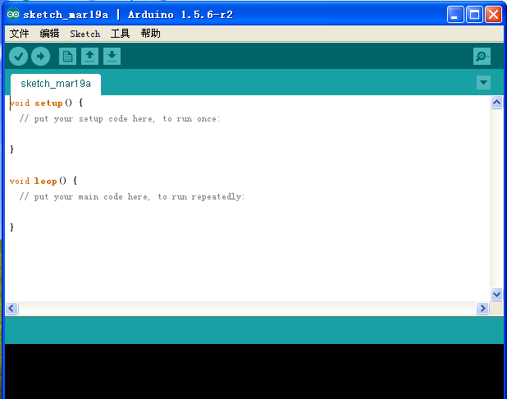

Next will be about the installation of Arduino driver.

